# Lab: Rest Services

Problems for in-class lab for the [“JavaScript Applications” course @ SoftUni](https://softuni.bg/trainings/2082/js-applications-november-2018). Submit your solutions in the SoftUni judge system at <https://judge.softuni.bg/Contests/358/REST-and-HTTP-Requests>. During this exercises you will **not** write **JS** code. **Install** “[Postman](https://www.getpostman.com/)” REST Client to **ease** your task.

**1. GitHub Repos for User "testnakov"**

First task is to list user's all public repositories. You will send a “**GET**” request to receive all the

repositories after that all you have to do is **copy** the response in JSON format and **paste** it as a

solution in **judge**.

**REQUEST**: <https://api.github.com/users/testnakov/repos>



**RESPONSE**:

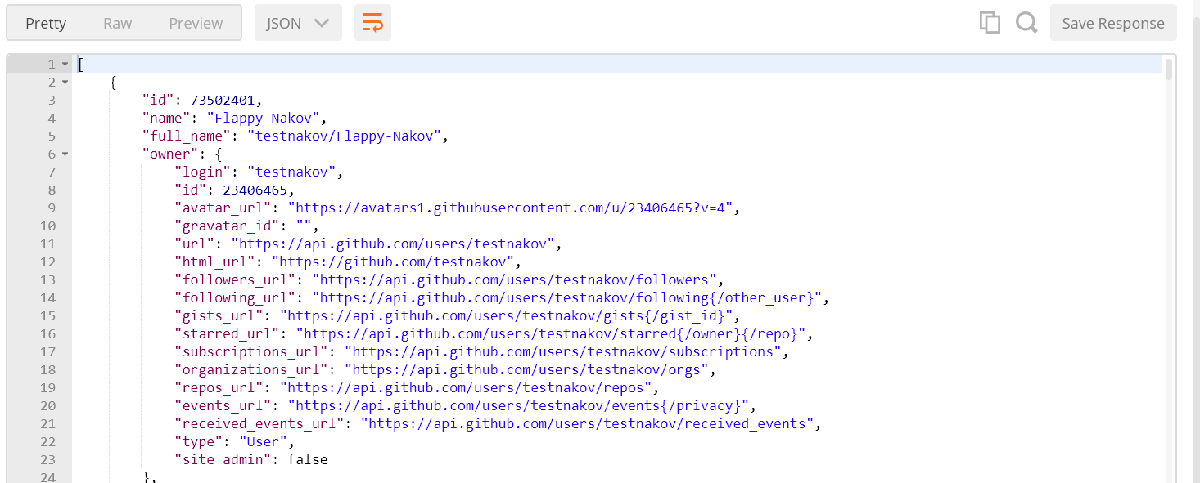

**2. GitHub: Labels Issue#1 (testnakov/test-nakov-repo)**

Get the **first** issue from repository with **name** “test-nakov-repo”. Send a GET request to https://api.github.com/repos/testnakov/test-nakov-repo/issues/:id, where :id is the issue.

**3. Github: Create Issue**

This time we have to **create** an issue (data should be **send** to the server). Send a “**POST**” request to the server with the following JSON as **body** (send it as application/json):

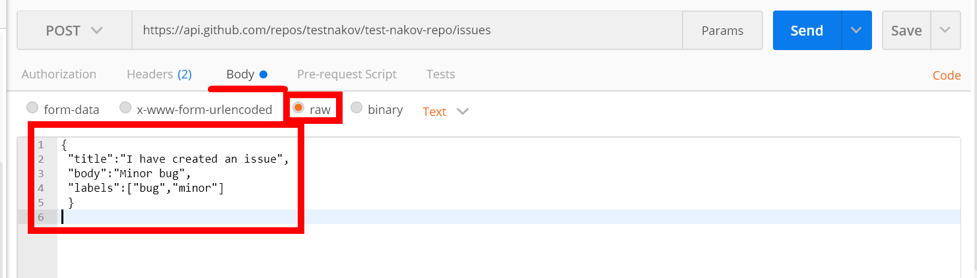

You need to use your GitHub **account credentials** to submit issues. Under the Authorization tab, select Basic and enter your username and password. Send the request to the URI from the previous task, but without the :id.

**4. Firebase: All Books**

Firebase is a cloud-based DB, **storage** and **app** platform (BaaS).

Register at: <https://console.firebase.google.com>.

Create a “**TestApp**” and in the create the **following** structure:

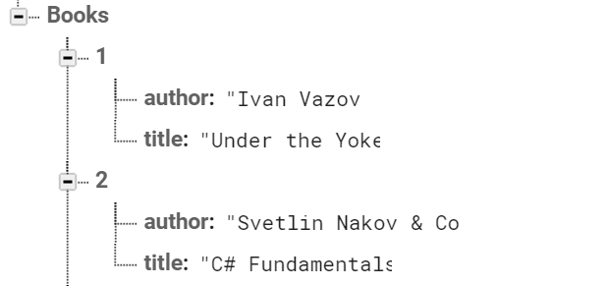

First task is to “**GET**” all books. To consume the request with **POSTMAN** your **url** should be the **following**: https://{databaseId}.firebaseio.com/.json.

**DatabaseId** is unique for every application. You can **find** yours from here:

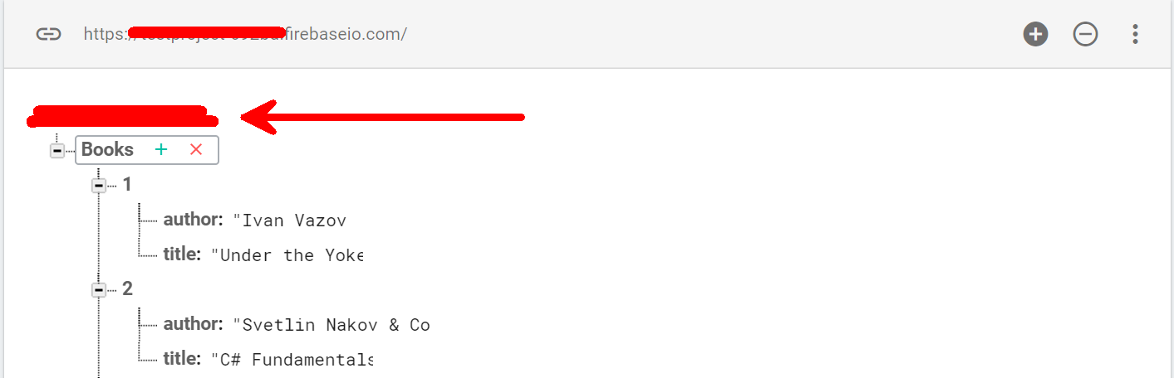

We **should** also do one more configuration. Go to Database/Rules and set **.read** & **.write** actions to “**true**”. This will allow us to **send** request with **POSTMAN**. Beware that now everyone can **manipulate** our database and even **delete** it. (this is for **testing** purposes only).

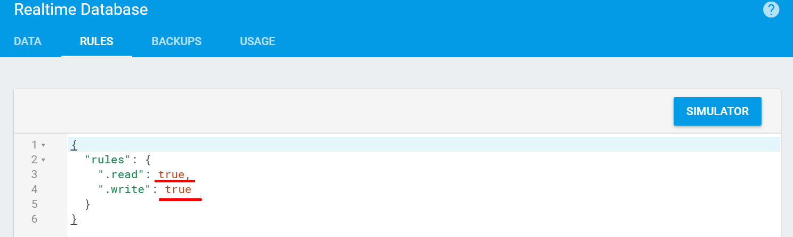

**5. Firebase: Get Book #1**

“**GET**” the Book with **id**: 1. Don’t forget the **.json** extension at the end (otherwise you will receive the whole **html**).

**6. Firebase: Create Book**

To **create** a book, we will have to send a “**POST**” request and the JSON body should be in the **following** format:

{

"title":"New Title",

"author":"New Author"

}

**7. Firebase: Patch Book #7**

The HTTP command “**PATCH**” **modifies** an existing HTTP **resource** (it can also create the resource if it does **not** exist). The JSON body should be in the **following** format:

{

"year": 1981,

"author": "Author Changed"

}

**8. Firebase: Change Book #7 Author**

This time we have to execute a “**PUT**” command (the difference is that with “**PUT”** we can update a resource **partially**). In our case we have to **change** the author’s name to "**New author was assigned**".

**REQUEST**: https://{databaseId}.firebaseio.com/Books/7/author/.json

The JSON body should be in the **following** format:

"**New author was assigned**".

**9. Kinvey: Handshake**

Kinvey is a **Mobile Back-End** as a Service (mBaaS).

Create a **developer** account in **Kinvey** at: <https://console.kinvey.com/sign-up>.

After registration **create** an app called “**MyApp**” and afterwards click “**Development**”.

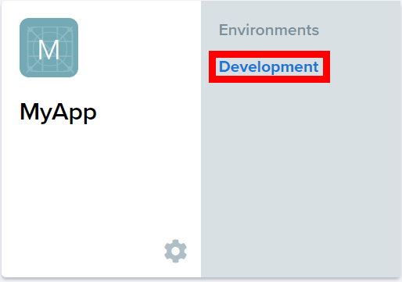

We receive an **appId** and **appSecret** that we will use later:

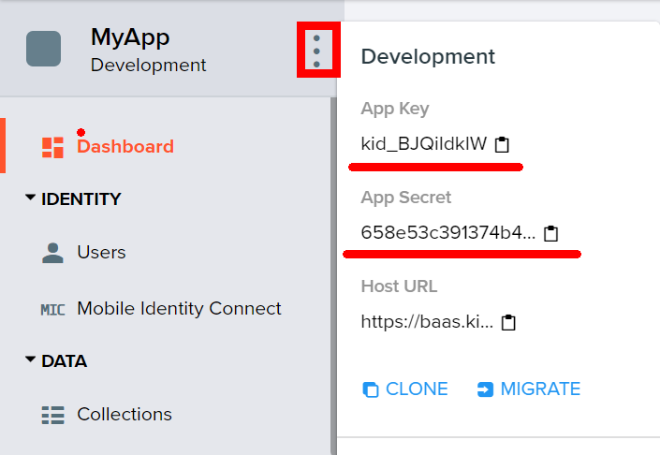

Create a **new** user in the “Users” **section** with username: “**guest**” and password: “**guest**”.

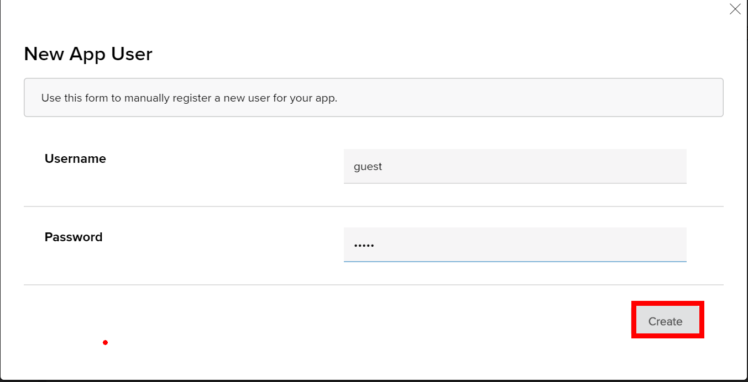

To fulfill a **handshake,** we have to enter the following “**GET**” request in **POSTMAN**: [https://baas.kinvey.com/appdata/{appId}](https://baas.kinvey.com/appdata/%7bappId%7d). Enter your own **appId**.

**10. Kinvey: All Posts**

Create a **new data collection** called “**posts**” that has **two** columns: “**title**” and “**body**” and add 3 **rows** of information.

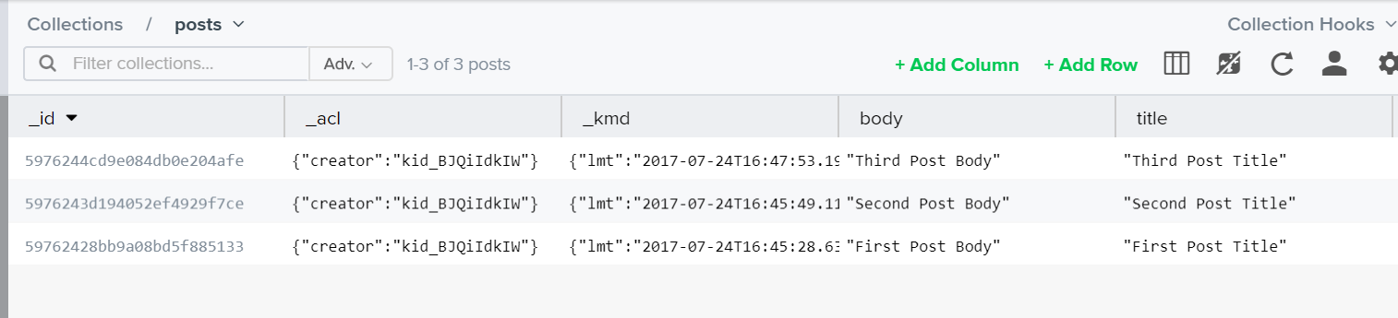

After that **listing** all posts should be easy **with** the following request: [https://baas.kinvey.com/appdata/{appId}/posts](https://baas.kinvey.com/appdata/%7bappId%7d/posts)

**11. Kinvey: Create New Post**

Firstly, go to **Authorization** in **POSTMAN** and select “**Basic Auth**”. And enter **username**: “guest” and **password**: “guest”.

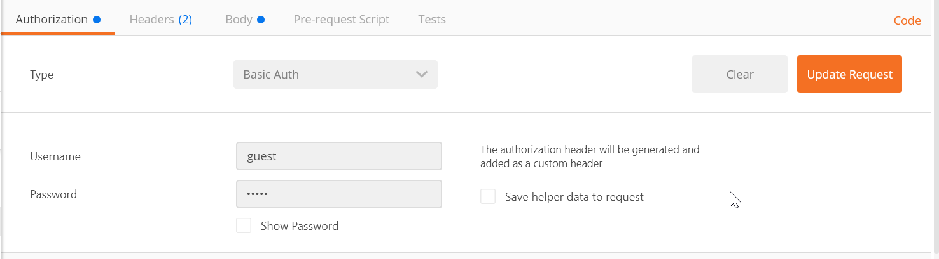

We already know the request method for **creating** a new resource. Now we should create a **new** post with a **title**: “New Title” and a **body**: “New Post Body”.

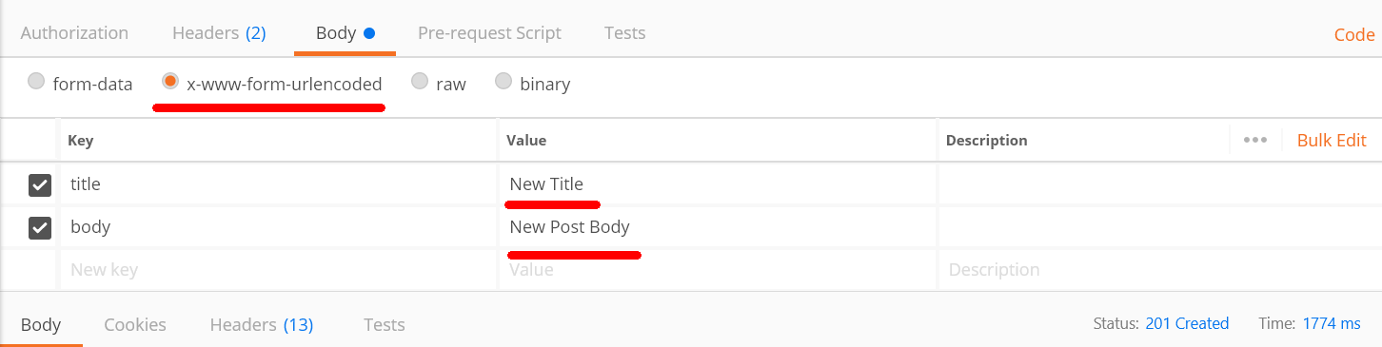

**12. Kinvey: Delete a Post**

Now let us **delete** the **newly** created post.

**REQUEST “DELETE”:** [https://baas.kinvey.com/appdata/{appId}/posts/{postId}](https://baas.kinvey.com/appdata/%7bappId%7d/posts/%7bpostId%7d). The **postId** can be found from the JSON response of the **previous** task. The “**DELETE**” request should **generate** a response that tells us how **many** posts we have **deleted**.

**13. Kinvey: Edit a Post**

Edit a Post with a “**PUT**” request. **Change** the following columns: **title**: “edited title”, **body**: “edited author” and add an additional column: **hidden**: true.

**14. Kinvey: Login**

Change the **Authorization** to “**No Auth**”. **Logging** in is done with a “**POST**” request with the **following** url: [https://baas.kinvey.com/user/{appId} /login](https://baas.kinvey.com/user/%7bappId%7d%20/login).

You should also send your **credentials** through the JSON **body**:

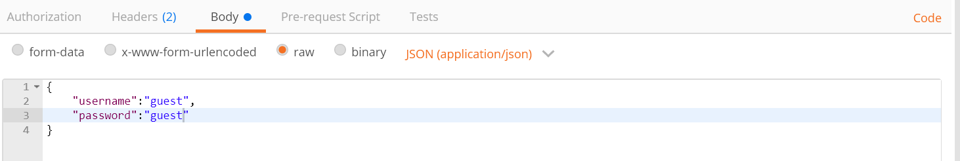

After a **successful** login you should **receive** the following response:

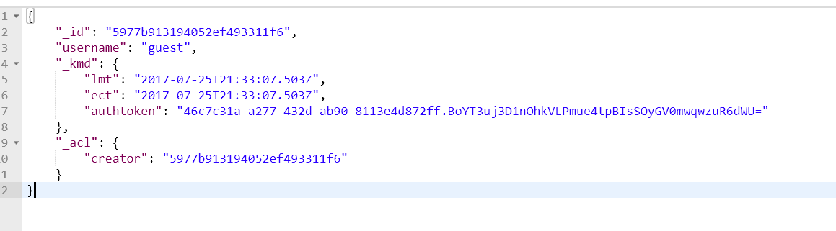

Save the **authtoken**, because you will **need** it for the **final** task.

**15. *Bonus Kinvey: Logout**

Lastly we have to **logout** from the application. To do so we have to send a “**POST**” request with the **following** url: [https://baas.kinvey.com/user/{appId}/_logout](https://baas.kinvey.com/user/%7bappId%7d/_logout).

Remember that long **authorization** token ? Now we have to copy it and paste it in the **POSTMAN** **“Headers”** section:

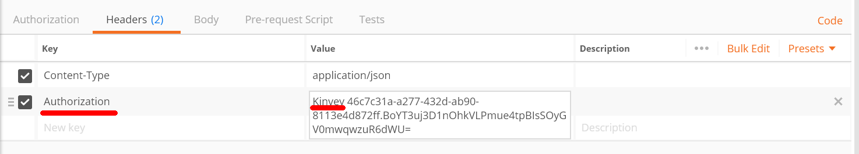

After you click “**Send**” the response body **should** be **empty**. Doing it **again** should trigger an **error**.